**AIM:**

To design the mobile features using html css and javascript.

**SOFTWARE REQUIRD:**

* Visual Studio Code
* Google Chrome Web Browser

**ALGORITHM:**

**STEP 1 :** Open Visual Studi Code.

**STEP 2 :** Create mobile.html as a home page.

**STEP 3 :** Create style.css for designing the html page.

**STEP 4 :** Link the style.css in the mobile.html.

**STEP 5 :** Include the images in the mobile.html using the <img src=”__”> tag

and insert the images.

**STEP 6 :** Include <script> tag for including the coding for javascript in the html

File.

**STEP 7 :** Run the mobile.html in the web server.

**STEP 8 :** Stop the program.

**PROGRAM:**

*mobile.html*

*<html>*

*<head>*

*<title>Mobile Features</title>*

*<link rel="stylesheet" type="text/css" href="style.css">*

*</head>*

*<body>*

*<div class="main">*

*<nav>*

*<div class="logo">*

*<img src="images/logo.png">*

*</div>*

*<div class="nav-links">*

*<ul>*

*<li><a href="#">Home</a></li>*

*<li><a href="#">Phone</a></li>*

*<li><a href="#">Accessories</a></li>*

*<li><a href="#">Cart</a></li>*

*</ul>*

*</div>*

*</nav>*

*<div class="information">*

*<div class="overlay"></div>*

*<img src="images/mobile.png" class="mobile">*

*<div id="circle">*

*<div class="feature one">*

*<img src="images/camera.png">*

*<div>*

*<h1>Camera</h1>*

*<p>48MP, Wide Angle Lens</p>*

*</div>*

*</div>*

*<div class="feature two">*

*<img src="images/processor.png">*

*<div>*

*<h1>Processor</h1>*

*<p>Snapdragon Octa-core 11nm</p>*

*</div>*

*</div>*

*<div class="feature three">*

*<img src="images/display.png">*

*<div>*

*<h1>Display</h1>*

*<p>6.5" Mini-Drop Fullscreen</p>*

*</div>*

*</div>*

*<div class="feature four">*

*<img src="images/battery.png">*

*<div>*

*<h1>Battery Life</h1>*

*<p>5000mAh, 720hrs Standby</p>*

*</div>*

*</div>*

*</div>*

*</div>*

*<div class="controls">*

*<img src="images/arrow.png" id="upBtn">*

*<h3>Features</h3>*

*<img src="images/arrow.png" id="downBtn">*

*</div>*

*</div>*

*<script>*

*var circle=document.getElementById("circle");*

*var upBtn=document.getElementById("upBtn");*

*var donBtn=document.getElementById("downBtn");*

*var rotateValue = circle.style.transform;*

*var rotateSum;*

*upBtn.onclick = function()*

*{*

*rotateSum= rotateValue + "rotate(-90deg)";*

*circle.style.transform = rotateSum;*

*rotateValue = rotateSum;*

*}*

*downBtn.onclick = function()*

*{*

*rotateSum = rotateValue + "rotate(90deg)";*

*circle.style.transform = rotateSum;*

*rotateValue = rotateSum;*

*}*

*</script>*

*</body>*

*</html>*

*style.css*

*\*{*

*margin: 0;*

*padding: 0;*

*font-family: sans-serif;*

*}*

*.main{*

*width: 100%;*

*height: 100vh;*

*position: relative;*

*overflow: hidden;*

*background: linear-gradient(to right, #9c27b0, #8ecdff);*

*}*

*nav{*

*width: 80%;*

*position: sticky;*

*margin: 20px auto;*

*z-index: 1;*

*display: flex;*

*align-items: center;*

*}*

*.logo{*

*flex-basis: 20px;*

*}*

*.logo img{*

*width: 150px;*

*}*

*.nav-links{*

*flex: 1;*

*text-align: right;*

*}*

*.nav-links ul li{*

*list-style: none;*

*display: inline-block;*

*margin: 0 20px;*

*}*

*.nav-links ul li a{*

*color: #fff;*

*text-decoration: none;*

*}*

*.information{*

*width: 1000px;*

*height: 1000px;*

*position: absolute;*

*top: 50%;*

*left: -10%;*

*transform: translateY(-50%);*

*}*

*#circle{*

*width: 1000px;*

*height: 1000px;*

*position: absolute;*

*top: 0%;*

*left: 0%;*

*border-radius: 50%;*

*transform: rotate(0deg);*

*transition: 1s;*

*}*

*.feature img{*

*width: 70px;*

*}*

*.feature{*

*position: absolute;*

*display: flex;*

*color: #fff;*

*}*

*.feature div{*

*margin-left: 30px;*

*}*

*.feature div p{*

*margin-top: 8px;*

*}*

*.one{*

*top: 450px;*

*right: 50px;*

*}*

*.two{*

*top: 150px;*

*left: 350px;*

*transform: rotate(-90deg);*

*}*

*.three{*

*bottom: 450px;*

*left: 50px;*

*transform: rotate(-180deg);*

*}*

*.four{*

*bottom: 150px;*

*right: 350px;*

*transform: rotate(-270deg);*

*}*

*.mobile{*

*width: 200px;*

*position: absolute;*

*top: 50%;*

*left: 35%;*

*transform: translateY(-50%);*

*z-index: 1;*

*}*

*.controls{*

*position: absolute;*

*right: 10%;*

*top: 50%;*

*text-align: center;*

*transform: translateY(-50%);*

*}*

*.controls h3{*

*margin: 15px 0;*

*color: #fff;*

*}*

*#upBtn{*

*width: 15px;*

*cursor: pointer;*

*}*

*#downBtn{*

*width: 15px;*

*cursor: pointer;*

*transform: rotate(180deg);*

*}*

*.overlay{*

*width: 0;*

*height: 0;*

*border-top: 500px solid #fff;*

*border-right: 500px solid transparent;*

*border-bottom: 500px solid #fff;*

*border-left: 500px solid #fff;*

*position: absolute;*

*left: 0;*

*top:0;*

*}*

**OUTPUTS:**

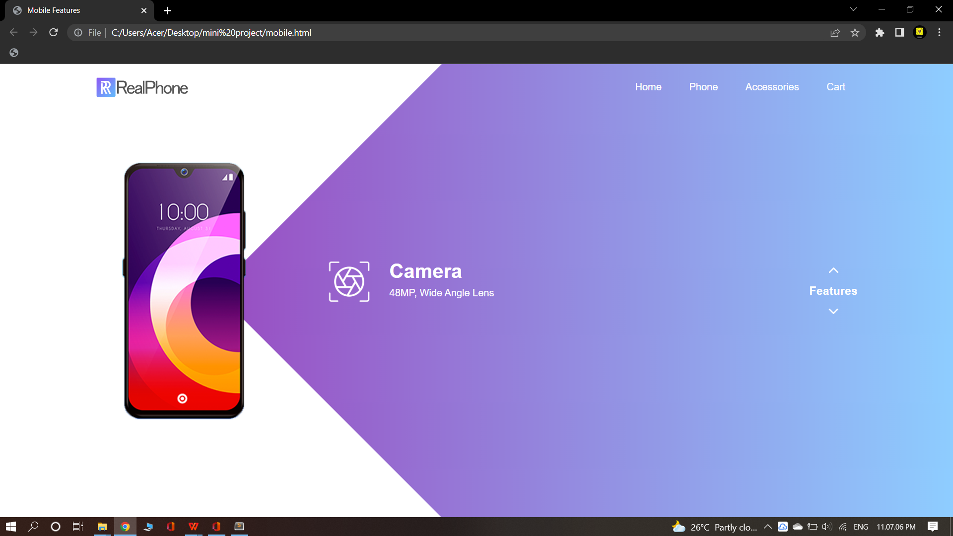

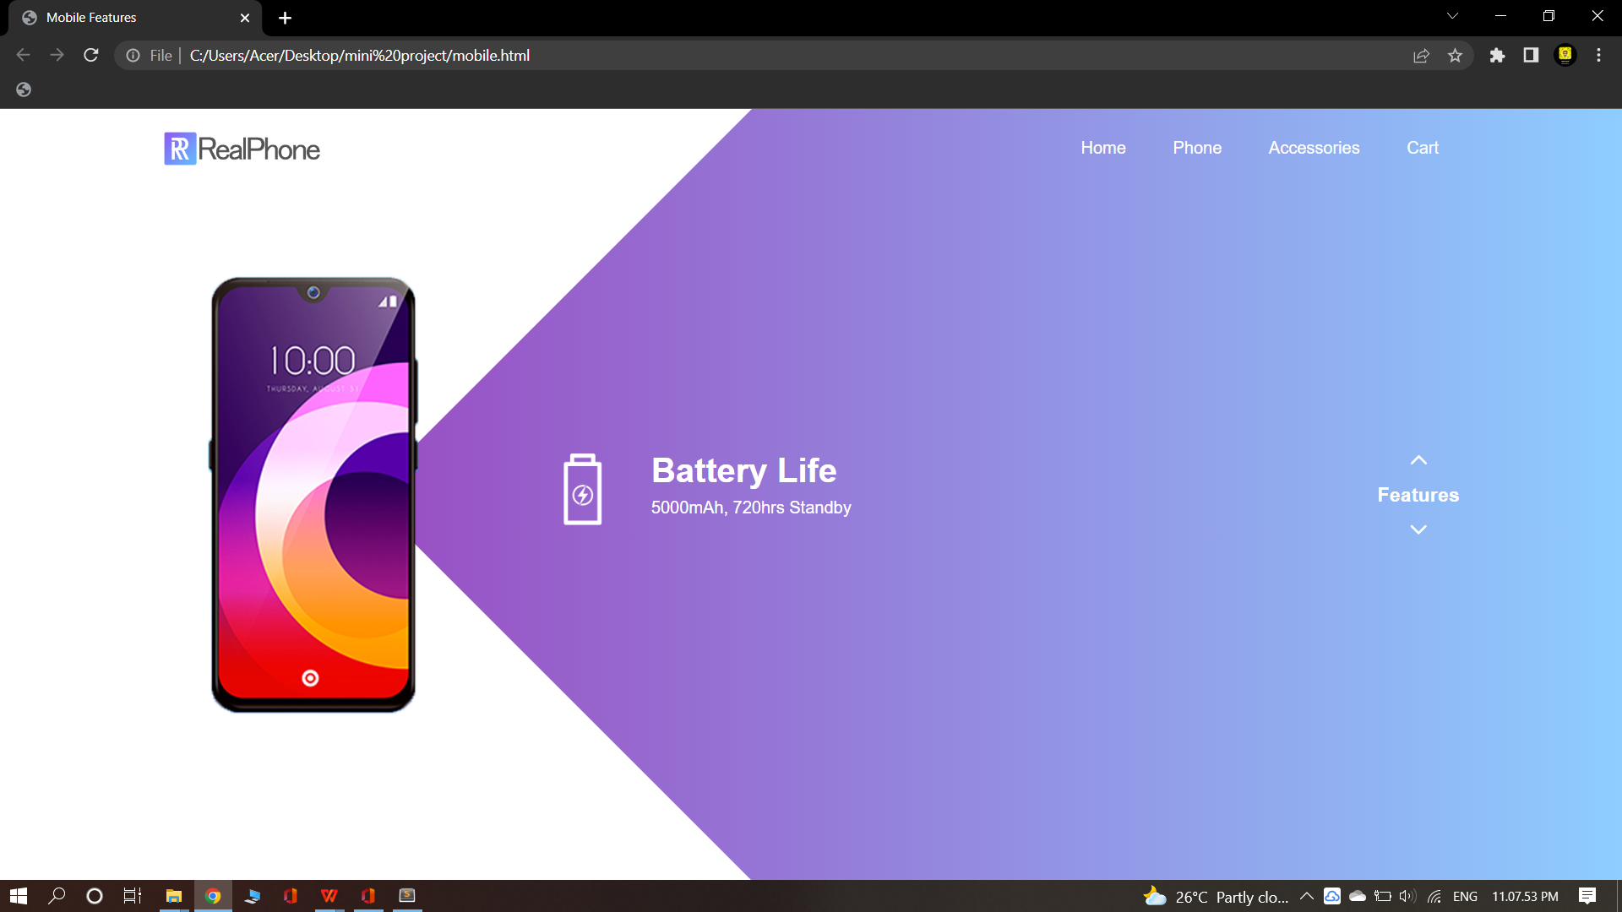 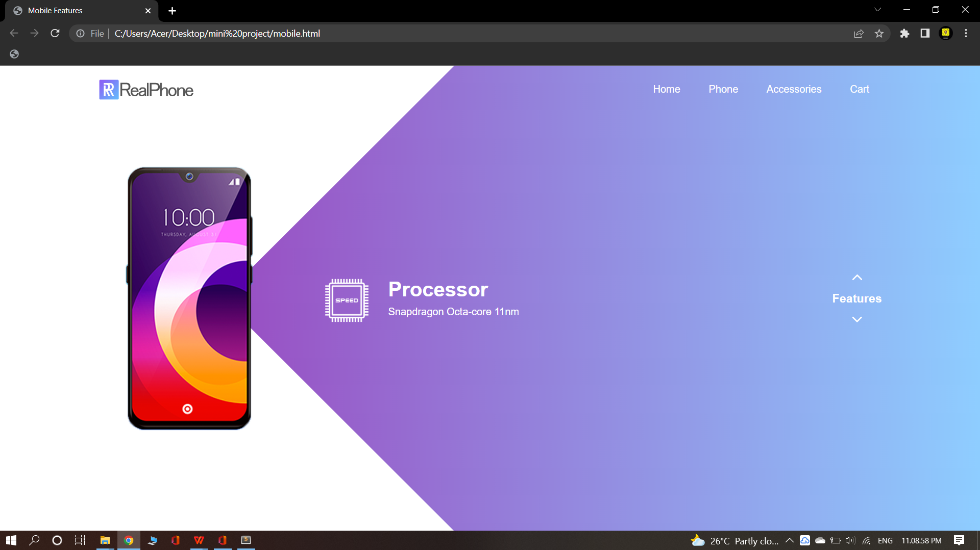



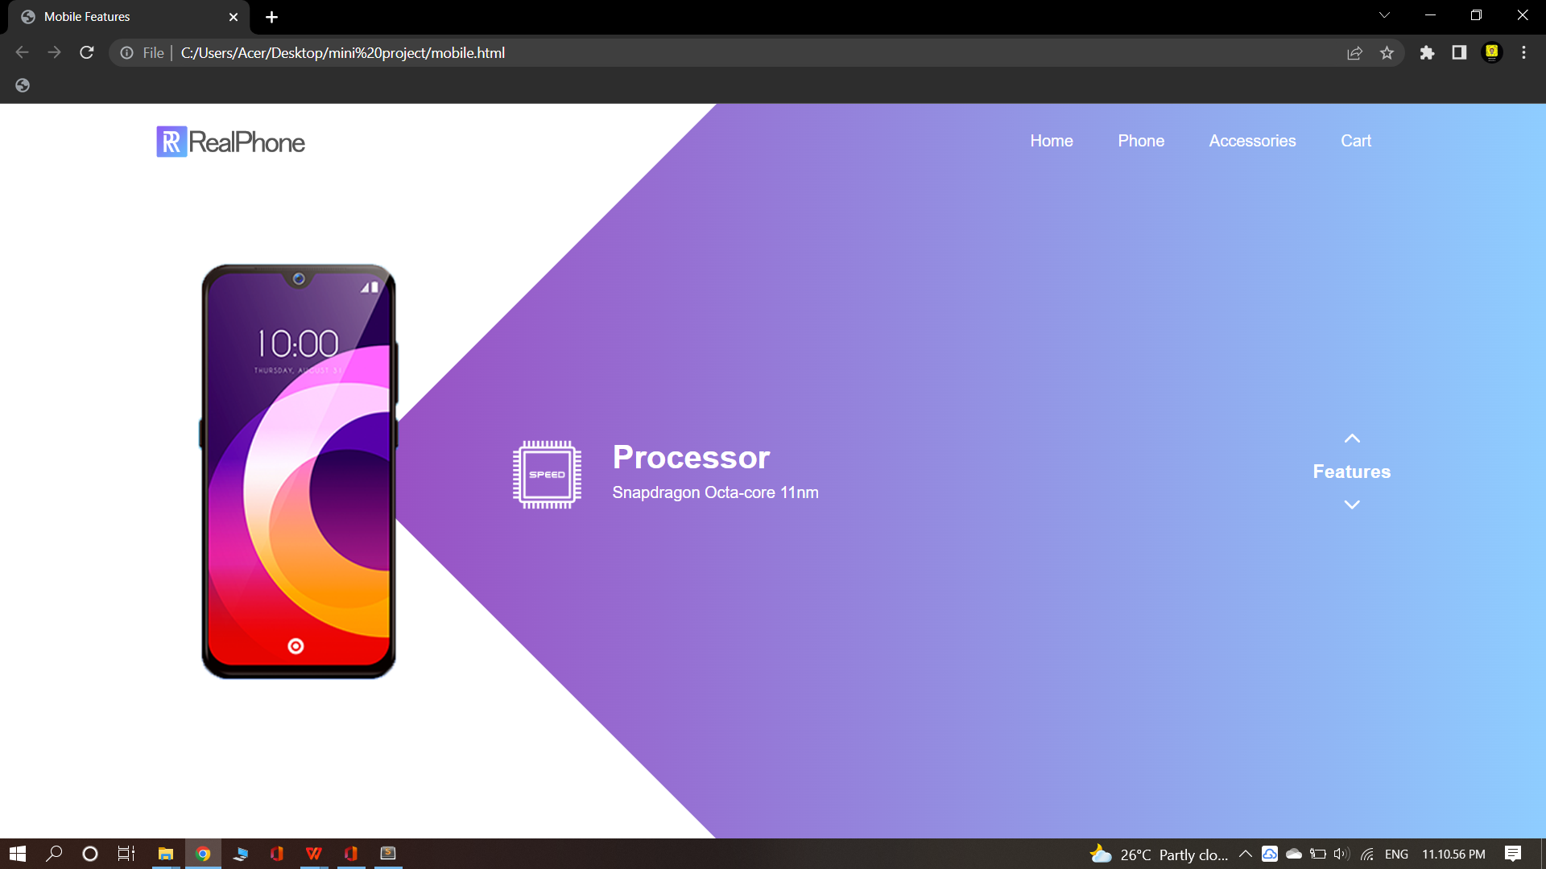

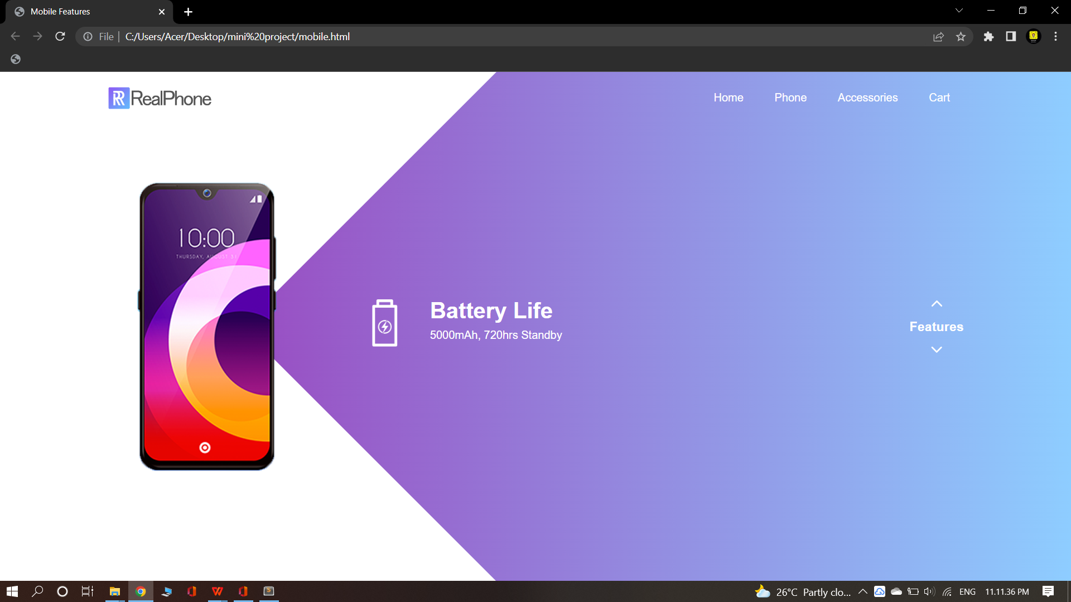

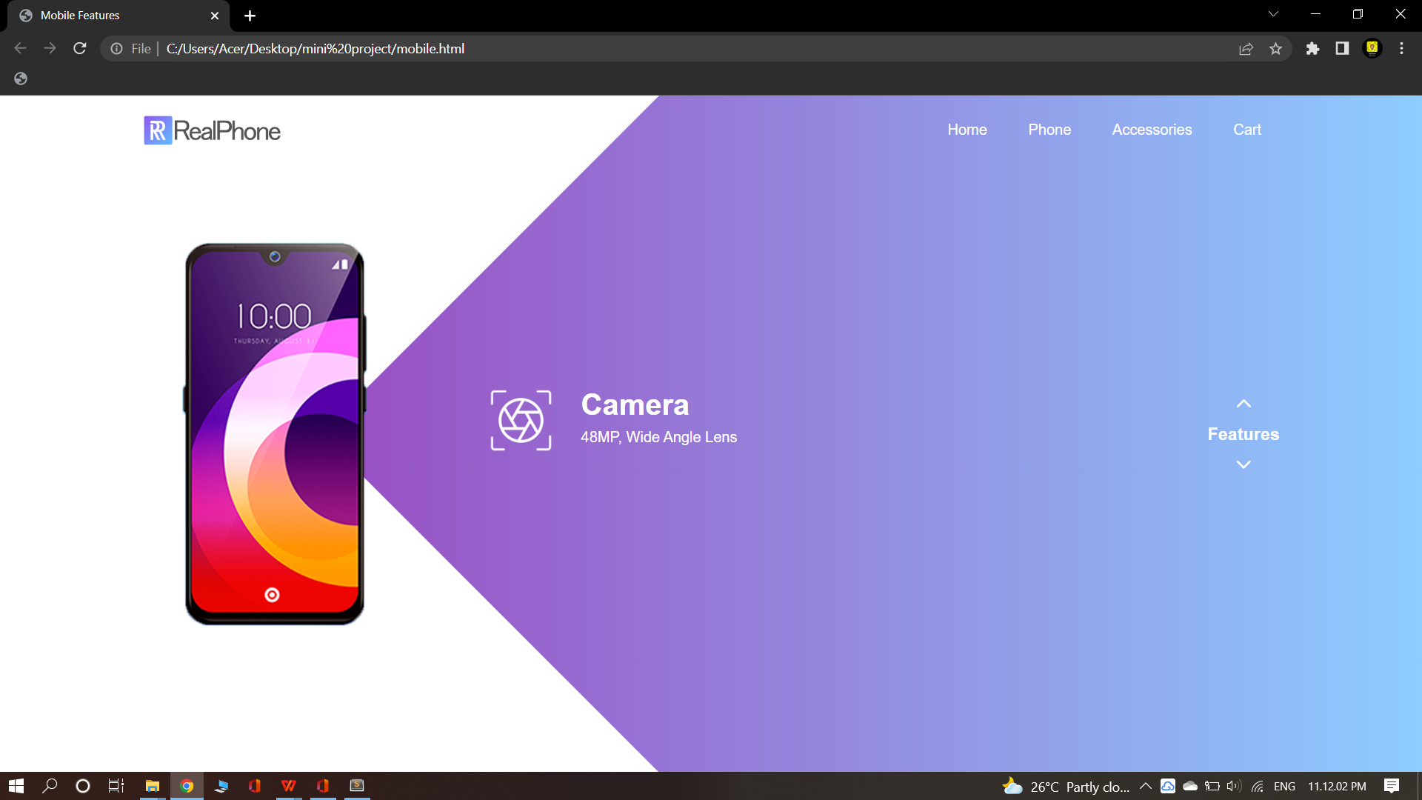

**RESULT:**

Thus the html page to show the features of a mobile is created using

HTML CSS and JavaScript and executed successfully.